**Spring Boot**

**Problem Statement:** Design and Develop a Bank Server Application with Core Java and

Collections Framework

**Description:** Develop a bank server application with the following functionalities:

1. Show Balance

2. Withdraw Money

3. Deposit Money

4. Transfer Funds (from one account to another)

5. Display Last 10 Transactions

**Requirements:**

1. Class Design: Create a class design before starting development. Define classes for

Customer, Account, and Transaction.

2. Customer-Account Relationship: Each customer has only one account, and each

account belongs to one customer.

3. Account Type: There is only one type of account available in the bank at the

moment, which can be termed as a savings account.

4. Input/Output Management: Since the application will run on a server, input and

output statements should be written only in the Main file. No other file/module

should contain input/output statements.

**Functionalities:**

1. Show Balance: Display the current balance of the account.

2. Withdraw Money: Allow the customer to withdraw money from their account.

Perform validations to ensure the balance does not go below zero.

3. Deposit Money: Allow the customer to deposit money into their account.

4. Transfer Funds: Enable the transfer of funds from one account to another. Perform

validations to ensure sufficient balance.

5. Display Last 10 Transactions: Show the last 10 transactions, including transaction

date, ID, amount, credit/debit status, available balance, and description.

Note: Implement validations wherever applicable, such as ensuring the balance of an

account cannot go below zero.

1. Develop the application using Core Java and utilize the **Collections Framework** for

managing transactions and accounts efficiently.

**2. Junit and Mockito**

Construct the Bank Server Application integrating JUnit and Mockito for testing

purposes. Include the Test cases for all 5 functionalities mentioned earlier.

**3. For JPA**

Build the Bank Server Application mentioned above, incorporating JPA for Data

Persistence and validations.

**4. For Spring MVC**

Develop the Bank Server Application as described earlier, utilizing Spring MVC and

integrating JPA for Data Persistence.

**5. For Spring Boot and Data JPA**

Construct the Bank Server Application utilizing Spring Boot and Data JPA as mentioned

earlier.

**6. For RestTemplate**

Create the Bank Server Application using Spring Boot and Data JPA as previously mentioned

and incorporate RestTemplate for handling HTTP requests.

**7. For RestAssured Testing**

Develop the Bank Server Application as described earlier, employing Spring Boot and Data

JPA, and integrate RestAssured for conducting API testing.

**8. For Open Feign**

Implement the Bank Server Application using Spring Boot and Data JPA and integrate

OpenFeign for making declarative RESTful web service calls.

**9. API Gateway**

Develop the Bank Server Application utilizing Spring Boot and Data JPA and

incorporate an API Gateway for routing and managing incoming requests to various

microservices.

**Requirement Analysis:**

Design and Develop a Bank Server Application with Core Java and Collections Framework

Develop a bank server application with the following functionalities:

1. Show Balance

2. Withdraw Money

3. Deposit Money

4. Transfer Funds (from one account to another)

5. Display Last 10 Transactions

**Design:**

**Code Implementation:**

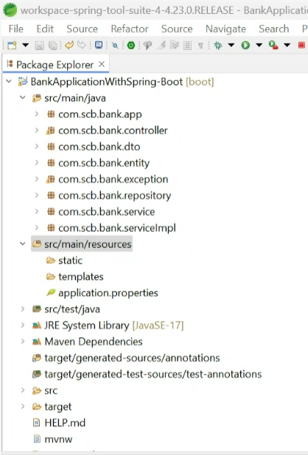

1.

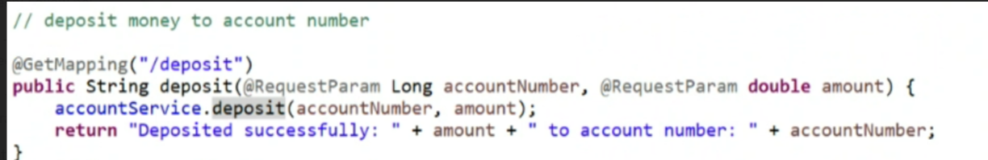

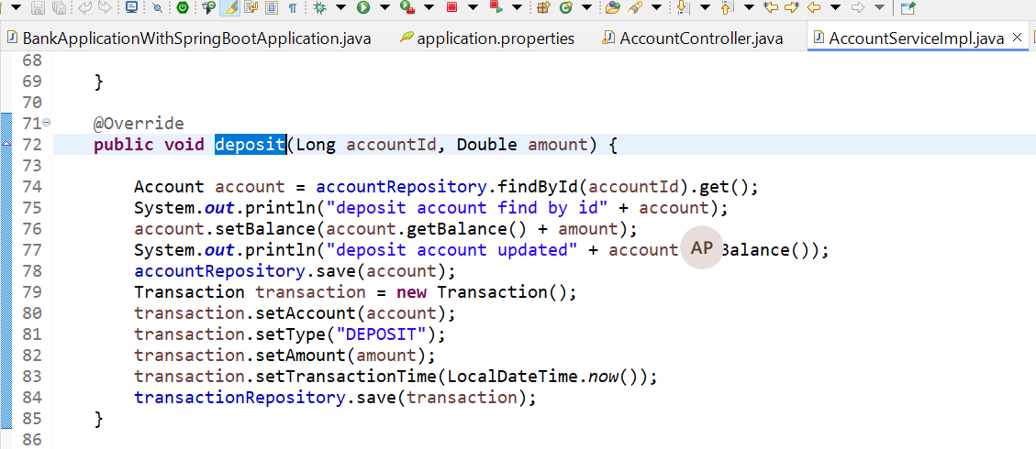

**Junit Testing :**

**Code Review:**